DATEROEM WOOD SALES
System Documentation
Website User Interface
The customer website: pages, features, files and build
Document | Website User Interface
Document number | DWS-WEB-02
Version | 1.1
Date | 25 October 2026
Intended readers | Developers, designers and the business owner
Classification | Internal - contains system design details; share only with authorised staff
Describes the customer website in frontend/website: every page and what a customer can do on it, the shared components and their files, the brand style, privacy and analytics, and how the site is built, previewed and published.

Document control
Version | Date | Change
1.0 | 3 October 2026 | First complete edition, written from the source code as it stood on this date.
1.1 | 4 October 2026 | Featured page instead of Marketing; campaign card and in-page jumps on product pages; new sign-in screen (username or email, checked emails, chosen usernames, Google sign-in on); support email on the Help page.
1.1 | 7 October 2026 | Help page: frequently asked questions, kept by admins in the desktop app, and a "Send us an email" form - a window opened by the email button on the Help and Bulk Orders pages; the Help page contacts above the questions. The company emblem as the site icon, and a footer with every way to reach the business.
1.1 | 8 October 2026 | Footer: the business TikTok and Instagram pages (@dateroem.woods) linked. Browser tab icon enlarged: the emblem now fills the whole icon.
1.1 | 9 October 2026 | Retired products disappear from the shop (catalogue, product page, most ordered) and cannot be ordered; past orders are unaffected.
1.1 | 9 October 2026 | Bulk Orders page: "What bulk orders look like" - a slideshow of example pictures kept by Marketers and admins in the apps.
1.1 | 9 October 2026 | The company phone number +254182995011 on the Help page, Bulk Orders page and footer (from the website server); the Bulk Orders WhatsApp button now opens the right chat.
1.1 | 17 October 2026 | Bulk Orders emails go to the orders desk; the phone number filled in for signed-in customers; phone numbers confirmed by an SMS code at sign-up and before a first order (Airtel numbers for now).
1.1 | 18 October 2026 | Calm error messages for visitors (apiErrorMessage) and the "We'll be right back" page; the cart cookie renamed after the products were renumbered.
1.1 | 20 October 2026 | The "Living Forest" colours, chosen by the board for a livelier green: a deeper, cleaner page green and lighter raised surfaces, the same in the phone and desktop apps. The cookie banner's Customize is a wood link instead of a warning red.
1.1 | 20 October 2026 | Colour themes: Forest (the default), Dark and Light from the Theme menu at the end of the top links, remembered in the browser and, for a signed-in customer, with the account. The product grid and the Featured banner fill the page at any width, the cards growing with the screen.
1.1 | 23 October 2026 | The About page sets out the company below the film: who we are with the registered facts, how we work (timber from farms across Central Kenya, milled in Nakuru), mission and vision, where to find us with a map link, and the founder with a photo frame; the same facts for search engines in index.html.
1.1 | 23 October 2026 | Order tickets (DW-7K3Q9P) on the payment screen, the order page and Ordered Goods; Track my order without signing in (the ticket and the last 3 digits of the phone); the driver and number plate show only when staff share them for that delivery.
1.1 | 24 October 2026 | My profile: photo, name, email, phone and password, the email and phone shown partly until Show; the photo in the account button; Choose a new password after an admin's reset.
1.1 | 24 October 2026 | Returns & Refunds, Privacy and Terms pages (/returns, /privacy, /terms), linked from the footer and at checkout; Cookie settings in the footer; ReachUs shared with About.
1.1 | 24 October 2026 | The founder's approved bio and two photos on the About page (portrait in the round frame, and a photo with a young tree).
1.1 | 25 October 2026 | The forest look, live since 25 October 2026: the forest behind every page, the entrance, wood cards with an amount, Add to cart and Order now, Featured as a young tree beside the products on wide screens, and the product page's journey and More from the forest.
1.1 | 25 October 2026 | The modern chat panel: the site's forest behind it, emblem header, welcome with suggestions, frosted bubbles and a rounded message bar; one-line lists in answers laid out properly.
Keep this document up to date: when a feature, setting or server changes, edit the matching section here and add a line to the table above.
Contents
1 Introduction 4
2 Pages 6
3 Shared components and state 8
3.1 Components (src/components) 8
3.2 State (src/context) 8
3.3 Helpers (src/core and src/api) 9
4 Feature notes 10
4.1 Buying and paying 10
4.2 Featured campaigns 10
4.3 Product page 10
4.4 Ratings 11
4.5 Signing in and signing up 11
4.6 Confirming the phone number (SMS code) 12
4.7 My profile and passwords 14
4.8 Order tickets and Track my order 15
4.9 Returns, Privacy and Terms 16
4.10 About page story 18
4.11 Help page and support email 20
4.12 Frequently asked questions 21
4.13 Send us an email 22
4.14 Bulk order pictures 23
4.15 Chat assistant and nudges 24
4.16 The chat panel (forest look) 25
5 Brand style 26
5.1 Company emblem 26
5.2 Footer 27
5.3 Colours, wood and icons 27
5.4 The forest look 28
6 Privacy and analytics 31
7 Configuration 32
8 Build, preview and publish 33
8.1 When something goes wrong 33
9 Development history 34

1 Introduction
The customer website is a React single-page application. Visitors browse products, read reviews, see what is featured, chat with the assistant, and - once signed in - order and pay with M-Pesa and follow their deliveries. It talks only to the website server (DWS-WEB-01) through the /svc prefix.
Item | Detail
Location | /root/fathersProject/frontend/website
Technology | React 18.3, React Router 6, Vite 5.4; plain CSS in one stylesheet; no UI library
Development server | npm run dev - http://localhost:5173 (with live reload)
Public build | npm run build then npx vite preview --port 4173, reached through Caddy and ngrok
Proxy | vite.config.js forwards /svc and /media to the website server (8000) and the M-Pesa callback path to the backend (8080)

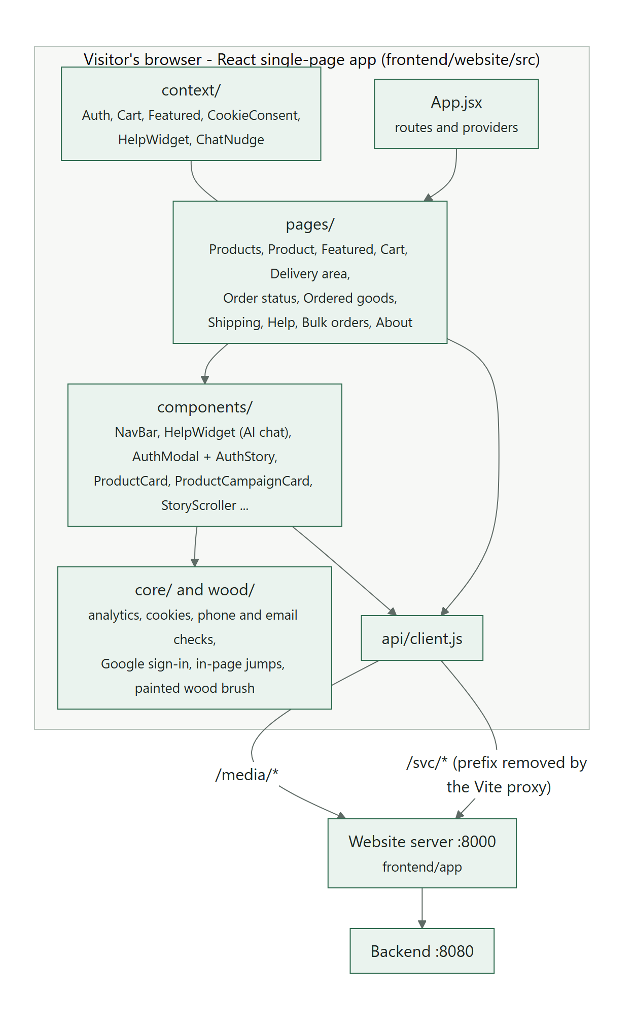
Figure 1: How the website code is organised

2 Pages
Routes are declared in src/App.jsx. Page components are in src/pages/.
Address | File | What the customer can do
/ | ProductsPage.jsx | Product grid that fills the page at any width - four cards across on a laptop, five on a wide monitor, growing with the screen (since 20 October 2026; it used to stop at 1360px against the left), search remembered while the tab is open, marketer badges, star ratings and a "Featured" tag on products in a running campaign. A banner names the running campaigns; closing it hides those campaigns on this browser until a new one starts. /?campaign=<id> shows only that campaign's products, with a note once it has ended. A search with no results can trigger the chat nudge. Products an admin has retired are not shown (since 9 October 2026); their page can't be opened and they can't be ordered, while past orders keep showing them.
/products/:productId | ProductDetailPage.jsx | Back arrow and "All products" link; photo, rating line, "Featured in ...", arranged description, stock, quantity with + and - only, Order Now (adds to cart), Go to cart. Below them: About this product, the campaign card, then the ratings (see Product page in section 4).
/featured | FeaturedPage.jsx | The campaigns running now as poster cards; videos play inside their own card and each card lists its products. The Featured link appears in the menu only while a campaign is running; the old /marketing address leads here.
/cart | CartPage.jsx | Cart lines with photos and quantity, total, delivery area (chosen on its own page), M-Pesa number checked as it is typed (filled in with the account's confirmed number), Place order. Sign-in is asked for only at this point.
/cart/area | AreaSelectPage.jsx | Full-page delivery area picker: search, grouped by city, "near me" using the browser location, map links. Returns to the cart with the choice.
/orders/:orderRef | OrderConfirmationPage.jsx | Order status after paying: polls for about two minutes, shows payment confirmed or the reason it failed, items and delivery message. The id in the address is masked.
/my-orders | MyOrdersPage.jsx | Ordered Goods: cards for orders not yet assigned, assigned (with the real delivery date) and delivered (recent first, older ones behind "Show older"); ratings panel beside them.
/track | TrackOrderPage.jsx | Track my order: the ticket and the last 3 digits of the account's phone, no sign-in; where the order is, in four steps.
/profile | ProfilePage.jsx | My profile: photo, name, email, phone number and password (24 October 2026).
/returns | PolicyPage.jsx | Returns & Refunds (24 October 2026) - the owner's refund rules.
/privacy | PolicyPage.jsx | Privacy - what the site keeps, why, who else sees it and the visitor's rights (Kenya's Data Protection Act, 2019).
/terms | PolicyPage.jsx | Terms - accounts, prices, paying, delivery, bulk orders, reviews and the assistant.
/shipping | ShippingPage.jsx | Read-only directory of pickup and delivery areas with maps.
/help | HelpPage.jsx | A button that opens the chat panel; under it the contact buttons - Send us an email (opens the email window), phone and WhatsApp - with the email address to copy; then the frequently asked questions (search, topic buttons, answers that open, a link to the page each is about).
/heavy-order | HeavyOrderPage.jsx | How to arrange a bulk (heavy) order with the team; under the introduction, "What bulk orders look like" - a slideshow of example pictures (see Bulk order pictures in section 4); then WhatsApp, call, or Send us an email (the same email window as the Help page, with the subject "Bulk order enquiry").
/about | AboutPage.jsx | Company story played by scrolling, then who we are, how we work, where to find us and the founder (see About page story in section 4).
Table 1: Website pages

3 Shared components and state

3.1 Components (src/components)
Component | Purpose
NavBar | Painted Dateroem wordmark, page links (Featured only while a campaign is running), cart icon with a dot when it has items, account icon; links fold behind a menu button on phones.
AuthModal | The full-screen sign-in and sign-up screen: the form on one side and the About film on the other (see Signing in and signing up). Escape closes it.
AuthStory | The About film inside the sign-in screen: Acquisition to Delivery with captions, progress bars and a pause button.
FeaturedBanner, ProductCampaignCard, CampaignVideo | The closable Products-page banner; the campaign card on a product page; the campaign video player, which remembers where each video was.
HelpWidget | The AI chat panel: messages, shortcut buttons, guest history, retry and fallback, nudge ring and label, "Asking about ..." line with one-tap questions.
CookieConsentBanner | Asks for the optional cookie categories (analytics, marketing): Accept all, Reject all and Customize. Customize is a wood-coloured link (since 20 October 2026; it used to share the red of Remove and Sign out, which made a normal choice look like a warning).
ThemeMenu | The Theme menu at the end of the top links (and at the bottom of the phone-width menu): Forest, Dark or Light, each with a small swatch; the one picked applies at once.
ProductCard, ProductRow, Stars, ProductReviews, ProductDescription | Product display pieces; ProductCard shows the Featured tag; ProductDescription shows the AI-arranged copy or tidies the original itself.
AreaPicker | Searchable, city-grouped delivery area list with distance from the visitor.
OrderRatings, ReviewModal | Rate delivered goods, edit or make ratings private; the public-review agreement must be scrolled to the end before it can be accepted.
StoryScroller | The About page animation engine (see About page story in section 4).
DriverNote | The driver's first name, the number plate and the company phone - only when staff shared the driver for that delivery.
ReachUs | Every way to reach the business (phone, WhatsApp, email, TikTok, Instagram) from GET /help/contact - on the About page and at the foot of each policy page.
Avatar | The account's photo in a circle, or the first letter of the name.
PasswordFields | Current password and the new one twice; keeps a new sign-in for this browser.
PasswordChangeGate | Covers the site after an admin's password reset until a new password is chosen.
ScrollManager | New pages start at the top; Back returns to the previous scroll position.
Icon, BackArrowIcon, WoodWordmark, Footer | Line icons (no emojis; WhatsApp, TikTok and Instagram drawn in the same style), back button, brand wordmark, footer (emblem and every way to reach the business).

3.2 State (src/context)
Context | Holds | Stored in
AuthContext | Signed-in user and token; checks the token with /auth/me on load; Google sign-in | localStorage dateroem_auth
CartContext | Cart lines with product photos | cookie dateroem_cart_v2 (strictly necessary; "_v2" since 18 October 2026, when the products were renumbered)
FeaturedContext | The campaigns running now, loaded once per visit, and which campaign a product is in | memory
CookieConsentContext | Which optional cookie categories the visitor allowed | localStorage dateroem_cookie_consent
ThemeContext | The colour theme on screen (forest, dark or light) | localStorage dateroem_theme; for a signed-in customer also the account (PUT /auth/me/theme), which wins when signing in or reloading
HelpWidgetContext | Whether the chat panel is open | memory
ChatNudgeContext | Nudge rules and the page the chat was opened from | sessionStorage dateroem_chat_nudges

Guest chat turns are kept in sessionStorage dateroem_guest_chat so a refresh does not lose the conversation. Closed Featured banners are remembered in localStorage dateroem.featuredHidden, and where each campaign video was in sessionStorage dateroem.videoTimes.

3.3 Helpers (src/core and src/api)
- api/client.js - every server call, all under /svc.
- core/phone.js - the same phone rules as the backend, so a number that passes here is never rejected later.
- core/policies.js - the words of the three policy pages and their date (POLICY_UPDATED).
- core/email.js - the email format check and spelling suggestions at sign-up (for example gmial.com becomes gmail.com). The backend checks the address again, including its mail domain.
- core/jumpTo.js - the in-page links of the product page (see Product page).
- core/orderRef.js - masks the order id shown in the address bar (not a security measure; the backend checks ownership).
- core/googleSignIn.js - loads Google's sign-in script only when the sign-in screen opens.
- core/analytics.js, core/cookies.js - Google Analytics and cookies, both gated by consent.
- core/geo.js, core/deliveredGoods.js, core/reviewConsent.js, core/aboutStory.js - distances, delivered-goods ordering, review agreement text and version, About page words (also used by the sign-in film).

4 Feature notes

4.1 Buying and paying
- Browsing and building a cart need no account.
- Products go into the cart from the product page or, in the forest look, straight from a product card (an amount, then Add to cart or Order now).
- At "Place order" the visitor signs in or signs up (phone number required).
- The delivery area is required; the M-Pesa number is checked before anything is sent.
- The order is created only if the M-Pesa prompt is sent successfully; the status page then follows the payment (see DWS-BE-03).
- Paid orders appear in Ordered Goods with a delivery estimate (3 weeks, or 3 months for very large items) until an admin schedules a real date.

4.2 Featured campaigns
Customers see campaigns where they already shop instead of on a separate "Marketing" tab, and only while a campaign is running: its status is Active, today is within its start and end dates, and it promotes at least one product that is not in the bin. The website server applies this rule (DWS-WEB-01), so drafts, paused or ended campaigns and campaigns without products never reach the browser. Staff choose a campaign's products in the phone app or the desktop app.
Where | What the customer sees
Featured page (/featured) | Every running campaign as a poster card with its products. The menu link appears only while at least one campaign is running.
Products page | A banner naming the running campaigns, which the visitor can close; a "Featured" tag on each product in one. In the forest look: a column with a young tree beside the products on wide screens, a card above them on narrower ones; closing it leaves a way back (see The forest look).
Product page | "Featured in <campaign>" under the product name and the campaign card further down (see Product page).
Chat assistant | Mentions a promotion only while it is running and points to the Featured page (DWS-BE-04).

4.3 Product page
The product's own details come first: photo, name, rating line, "Featured in ...", description, price, stock and Order Now. Below them, in this order: "About this product" (only for long descriptions), the campaign card when the product is in a running campaign with an image or video, and the Ratings section.
- Getting back. The back arrow returns to wherever the visitor came from; a page opened from a shared link has nowhere to go back to inside the site, so the arrow then goes to the products. "All products" always opens the full catalogue.
- The campaign card (ProductCampaignCard.jsx) is as wide as the About box (900 px). Its media stands on a stage at least as wide as it is tall, up to 440 px high, so an upright phone video is shown whole in the middle with a soft blurred glow of itself either side (drawn into a small canvas); wide media fill the stage. On a phone the stage takes the media's own shape. Other products in the campaign are listed as links, with "See all featured".
- The video keeps its place. CampaignVideo.jsx remembers how far each campaign video has played and whether it was playing, for the whole visit, so moving to another product in the same campaign carries on where it was. The card also remembers each video's shape, so coming back does not make the page jump.
- In-page links. "4.4 · 5 ratings", "Featured in ..." and "Read the full description" scroll to their section without adding a Back step, so Back still returns to the list. Because the campaign card arrives a moment after the ratings and then grows to the video's shape, core/jumpTo.js keeps the chosen section on the same spot of the screen for up to 15 seconds while the page fills in, and lets go as soon as the visitor scrolls. Keyboard users land on the section, which gets a wood-coloured outline.

4.4 Ratings
Delivered products appear under "Rate your goods". A rating is private by default; making it public requires reading the agreement to the end and accepting it, after which the first name and last-name initial are shown. Ratings can be edited or made private later. A product shows its average, star breakdown and public reviews once 3 customers have rated it (MIN_RATINGS_TO_SHOW in the backend's ReviewService.java); before that the product page says "No ratings yet". Private ratings count in the numbers and are mentioned only as a count.
Where to adjust: Agreement text and version: src/core/reviewConsent.js. The version must match CONSENT_VERSION in the backend's ReviewService.java.

4.5 Signing in and signing up
Signing in opens a full-screen window: the form on the left and, on the right, the About film (Acquisition, Harvest, Value addition, Packaging and Delivery) with captions, progress bars and a pause button. On a computer the film plays every third large frame of the About animation with blended in-between frames, about 5.6 seconds per chapter. Phones, data-saver connections and devices with animations switched off get one still picture per chapter that cross-fades instead, and on a phone the film is a strip above the form. Escape or the close button leaves; the page behind stays where it was.
Part | Rules
Sign in | Username or email, and password. The backend tries the username first; an email (a "+tag" address included) works when exactly one account uses it.
Sign up | Name, a username the person chooses (3 to 30 characters, no spaces, no @), password, phone number (required) and an optional email. An Airtel number is confirmed with an SMS code before the account is made (see Confirming the phone number).
Email at sign-up | A suggestion for common misspellings appears while typing ("Did you mean ...@gmail.com?"), and the format is checked when the field is left. The backend then checks it again: the format, that the domain can receive email, and that no other account already uses it. Addresses with a "+tag" (name+shop@gmail.com) are accepted.
Continue with Google | Shown above the form. A new Google user then chooses a username (same rule) and gives a phone number before the account is created. A Google account whose email already belongs to an account here is not joined to it; the person is asked to sign in with that account instead.

Google's own button appears when the backend reports a Google client id (/svc/auth/providers), so no website setting is needed. When no client id is set, or when the backend cannot be reached, a greyed "Continue with Google" stand-in takes its place with a short note, and visitors use their username or email instead.
Where to adjust: The client id is app.google.client-id in the backend's application.properties (default: the Dateroem web client in the Google Cloud project "Dateroem", owned by the business Gmail); GOOGLE_CLIENT_ID overrides it. It is not a secret.
Authorised JavaScript origins of that client: the public website address plus http://localhost:5173 and http://localhost:4173. Add any new public address there (Google Cloud Console, APIs and Services, Credentials).
While the Google app is in "Testing" only its listed test users can sign in. Publish it (Google Auth Platform, Audience, Publish app) so every Google user can.
Username rule: USER_NAME_RULE in src/components/AuthModal.jsx and USER_NAME in the backend's AuthService.java (change both). Spelling suggestions: src/core/email.js.

4.6 Confirming the phone number (SMS code)
"one may give a phone number not theirs ... push a code to the phone number they placed so that its verified ... so when prefilling it during payment is not wrong" - since 17 October 2026 a phone number counts as the customer's once they type the 6-digit code texted to it. For now this is for Airtel numbers only: Africa's Talking's shared sender reaches only Airtel, and Dateroem's own sender name (needed for Safaricom) is still to come. Other numbers are taken as typed, as before, and the sign-up form says which numbers get a code.
- Sign-up (password or Google): after Create account, a "Confirm your phone number" step - "We sent a 6-digit code by SMS to 07XX XXX 123". Typing (or pasting) the six digits checks it at once; the account is created only after the right code. Send a new code (after a minute) and Change number are under the box.
- A sign-up that fails for another reason (a username already taken) keeps the confirmed number for 30 minutes, so no second code is needed.
- Accounts made before (or whose number an admin changed): the cart says "Before your first order we'll text a code to confirm the phone number on your account", and Place order opens a "Confirm your phone number" window with the account's number, which can be changed. After the right code the order carries on.
- Checkout fills in the M-Pesa number only once it is confirmed (or when no code is needed for it). Wrong codes say how many tries are left; after five a new code is needed.

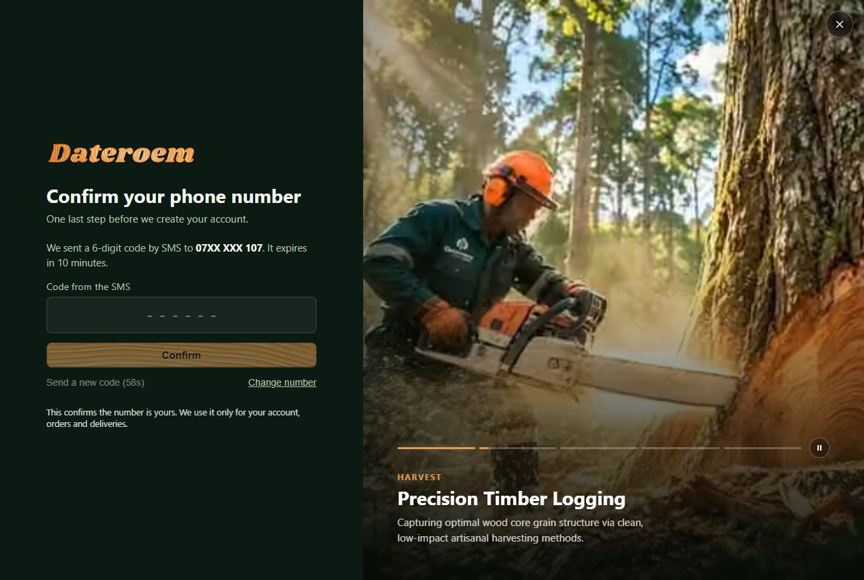
Figure 2: Sign-up: the code step (sample account)
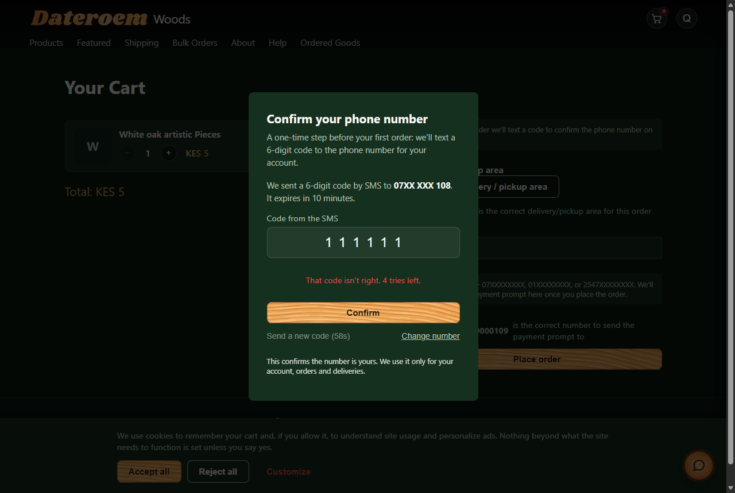
Figure 3: Checkout: confirming the number of an older account (sample data)
Where to adjust: The step: src/components/PhoneCodeStep.jsx (used by AuthModal.jsx and CartPage.jsx); calls in src/api/client.js (sendPhoneCode, verifyPhoneCode). Which networks get codes, the limits and the SMS wording are backend settings and code (see the Backend Server document).

4.7 My profile and passwords
Since 24 October 2026 the account menu (the photo or first letter at the top right) has My profile (/profile, pages/ProfilePage.jsx): the photo - picked on the device, cut to a centred 512 px square in the browser (core/profile.js squareJpeg) and sent to the website server, which stores it - the name and email (the password is asked for when the email changes), the phone number, the password, and a pointer to the Theme menu. The email and phone show partly (ja•••@gmail.com, 07•• ••• 678) until Show is pressed. A new phone number goes through the SMS code step (components/PhoneCodeStep.jsx) where codes are sent; staff accounts can't change their number here - an admin does. Changing the password (components/PasswordFields.jsx) keeps this browser signed in with a new token and signs every other device out. The photo shows in the account button (components/Avatar.jsx).
After an admin resets a password, the temporary one works only for choosing a new password: components/PasswordChangeGate.jsx covers the site with Choose a new password until that is done (or the person signs out).
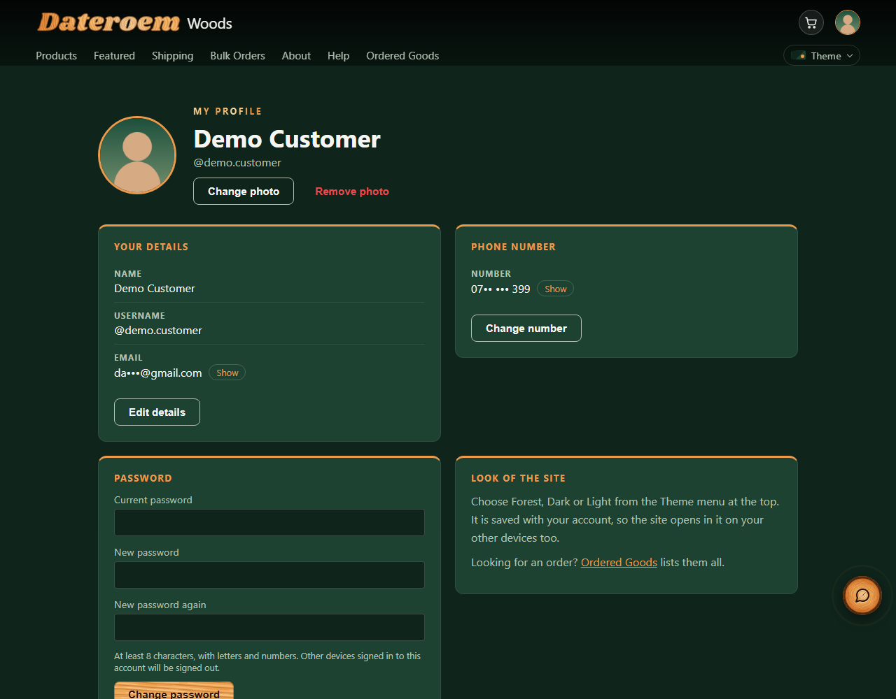
Figure 4: My profile with a made-up customer
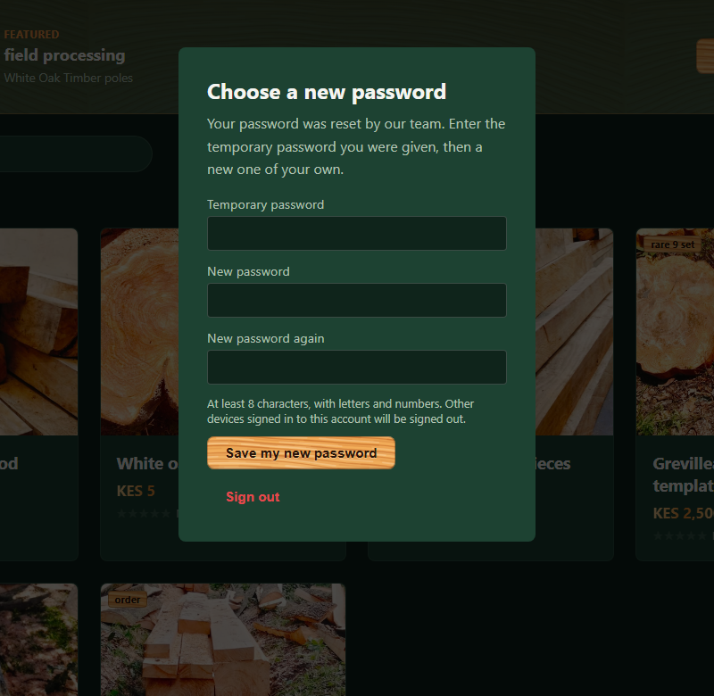
Figure 5: After a password reset: Choose a new password

4.8 Order tickets and Track my order
Since 23 October 2026 every order has a ticket like DW-7K3Q9P (migration 038): six letters and digits drawn at random, without the easily confused 0, O, 1, I and L, so it says nothing about how many orders exist and the next one can't be guessed. The customer sees it while M-Pesa confirms the payment, on the order page and on each order in Ordered Goods, and quotes it to the team; the assistant names orders by it too.
Track my order (/track, pages/TrackOrderPage.jsx) needs no sign-in: the ticket and the last 3 digits of the phone number on the account. It shows the order in four steps - placed, paid, on a delivery, delivered (or cancelled, or being rescheduled) - with the dates, the pickup area, the total and the items, never the customer's name or phone. Signed-out visitors find it in the top links where signed-in customers see Ordered Goods, and in the footer; the order page links to it with the ticket filled in. Only website orders can be tracked this way - orders staff open on a trip have no customer phone on record. Five wrong tries lock a ticket for half an hour and the page answers at most 60 look-ups a minute (the backend keeps count).
The driver and the vehicle are hidden from customers unless staff switch on Share driver for that delivery (desktop or phone). Then the order page, Ordered Goods and Track my order show the driver's first name, the number plate and the company phone number (components/DriverNote.jsx) - never the driver's own number.
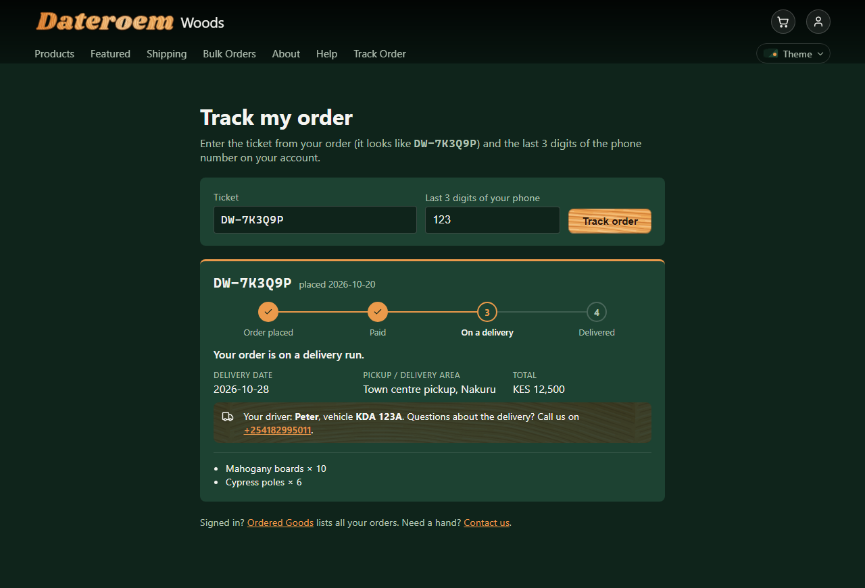
Figure 6: Track my order with a made-up order whose driver is shared

4.9 Returns, Privacy and Terms
Since 24 October 2026 the site has three policy pages, one layout (pages/PolicyPage.jsx) with the words in core/policies.js and the date at the top (POLICY_UPDATED). Returns & Refunds (/returns) holds the owner's rules: cancel any time before delivery - the full amount back if nothing has been cut or loaded yet, otherwise a cancellation cost agreed first; the full amount back if the latest delivery date passes; damaged, wrong or missing goods reported within 3 days with photos, replaced or refunded; no returns for a change of mind - only damaged goods; refunds to the same M-Pesa number within 3 working days of agreeing the amount; bulk orders fixed once agreed. Privacy (/privacy) lists what the system really keeps - the account (password stored scrambled), Google sign-in, orders with the M-Pesa number and receipt, the assistant's conversation, cookies - why, who else sees it (staff, Safaricom, Africa's Talking, Google, the assistant's AI service Groq), how long (orders at least five years, for tax), and the visitor's rights, including a complaint to the Data Protection Commissioner. Terms (/terms) covers accounts, prices, paying with M-Pesa, delivery dates, bulk orders, reviews and the assistant, under Kenyan law. Each page ends with every way to reach us (components/ReachUs.jsx, shared with About) and links to the other two.
The footer links Track my order, Returns & Refunds, Privacy, Terms and Cookie settings - the last opens the cookie banner again with the choices as they stand (reopen() in context/CookieConsentContext.jsx), which the Privacy page promises. Under Place order the cart says "By placing your order you agree to our Terms and Returns & Refunds". Help answers can link to the three pages, and the answer to "Can I change or cancel an order after paying?" now gives the short rules and links to Returns & Refunds.
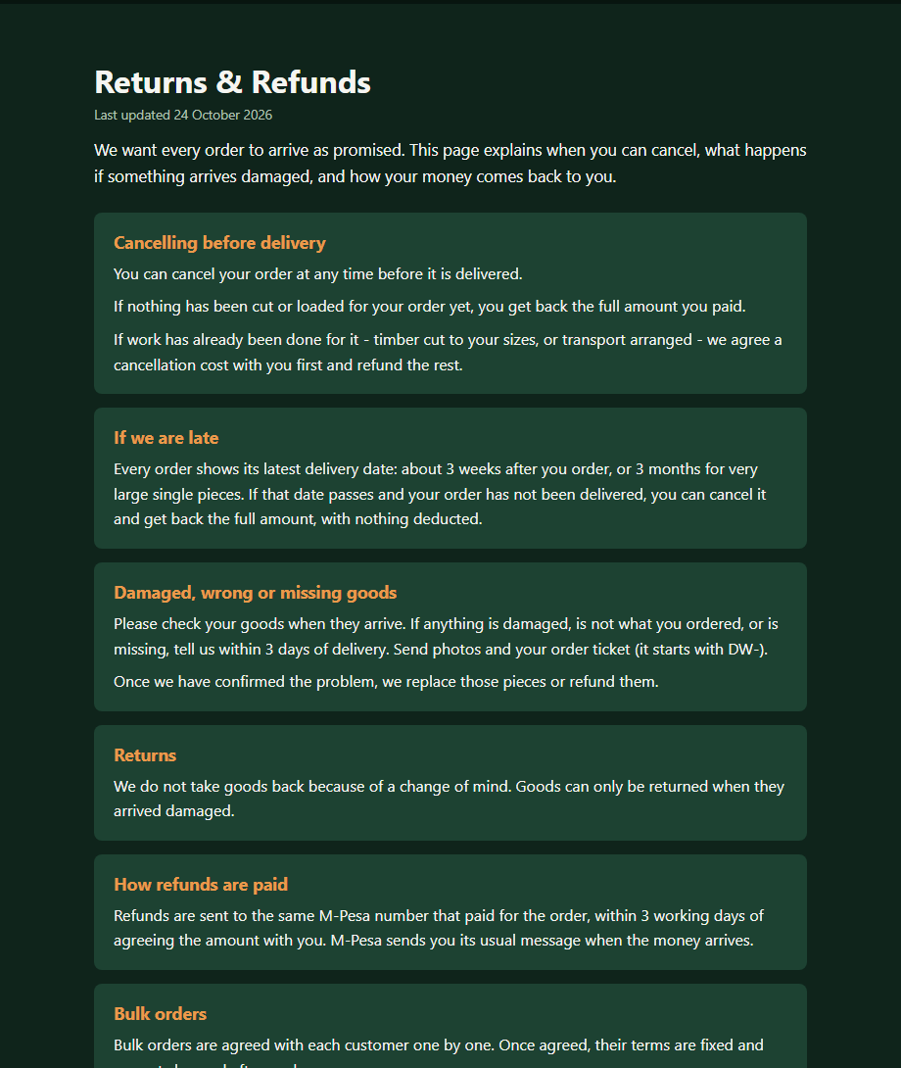
Figure 7: Returns & Refunds (Forest theme)
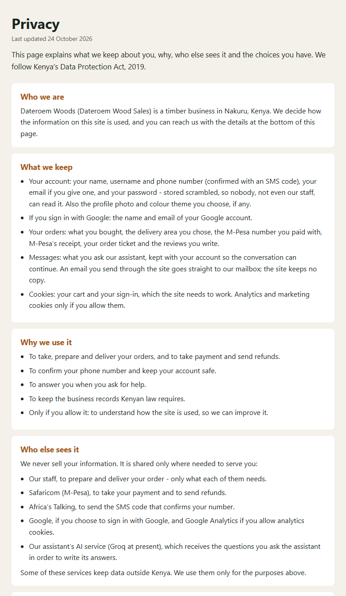
Figure 8: Privacy (Light theme)
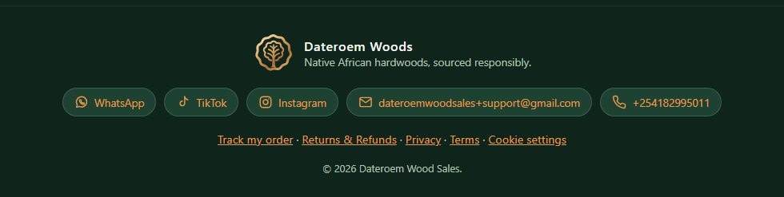
Figure 9: The footer with the policy links and Cookie settings

4.10 About page story
The About page plays a film of the business as the visitor scrolls: Acquisition, Harvest, Value addition, Packaging and Delivery, each with a card that flies in. Scrolling moves one stage at a time with smooth glides, and the dots allow jumping to a stage. Frames are drawn on a canvas that stays pinned while the section scrolls. The same frames play in the sign-in screen.
To change | Where
Words of the intro, stages and closing | src/core/aboutStory.js
The pictures | Source frames in /root/fathersProject/dateroem animations/frames; run scripts/build_story_frames.py to rebuild the web set in public/story/ (large, small and fallback sizes with a manifest)
Motion behaviour | src/components/StoryScroller.jsx (About page) and src/components/AuthStory.jsx (sign-in screen)

Note: Visitors who switch off animations in their device settings get a calm, motion-free version of the site. Windows on the company computer has animations switched off, so browsers there show the reduced-motion version.
Below the film (since 23 October 2026) the page sets out the company for customers and for payment-provider checks: Who we are, with the registered facts (business name, business registration number, the workshop in Nakuru and where the timber comes from - farms across Central Kenya); How we work in four numbered steps (sourcing, milling and finishing, ordering and paying, delivery); Our purpose (the mission and vision) beside a What we stand for card; Where to find us, with the workshop address, an Open in Google Maps button on the owner's own pin and a Reach us card with the company phone, WhatsApp, email and socials (from the website server's settings); and the founder, with a round photo frame (his approved bio and photos since 24 October 2026 - see below). The same day it was laid out again for big screens ("the rest need to be ordered good"): one centred column, every section with the words on the left and the facts in a card on the right, and the four steps on one line joined by a wood line (two by two on tablets, down a line on phones). The KRA PIN and personal phone numbers are deliberately left off the public page.
To change | Where
Company facts, the steps, the address, the founder words | src/core/aboutStory.js (ABOUT_COMPANY, ABOUT_HOW, ABOUT_LOCATION, ABOUT_FOUNDER)
The founder's photos | The round portrait is public/brand/founder.jpg (square, 800 x 800; while it loads the frame shows the company emblem - FounderPhoto in src/pages/AboutPage.jsx); the second picture is public/brand/founder-tree.jpg (640 x 800, shown 4:5 with a caption). Replace a file with one of the same name and size and rebuild the site. Photos are saved without camera or location data.
The same facts for search engines and payment checks | index.html (the Organization block, application/ld+json) - keep it in step with the About page

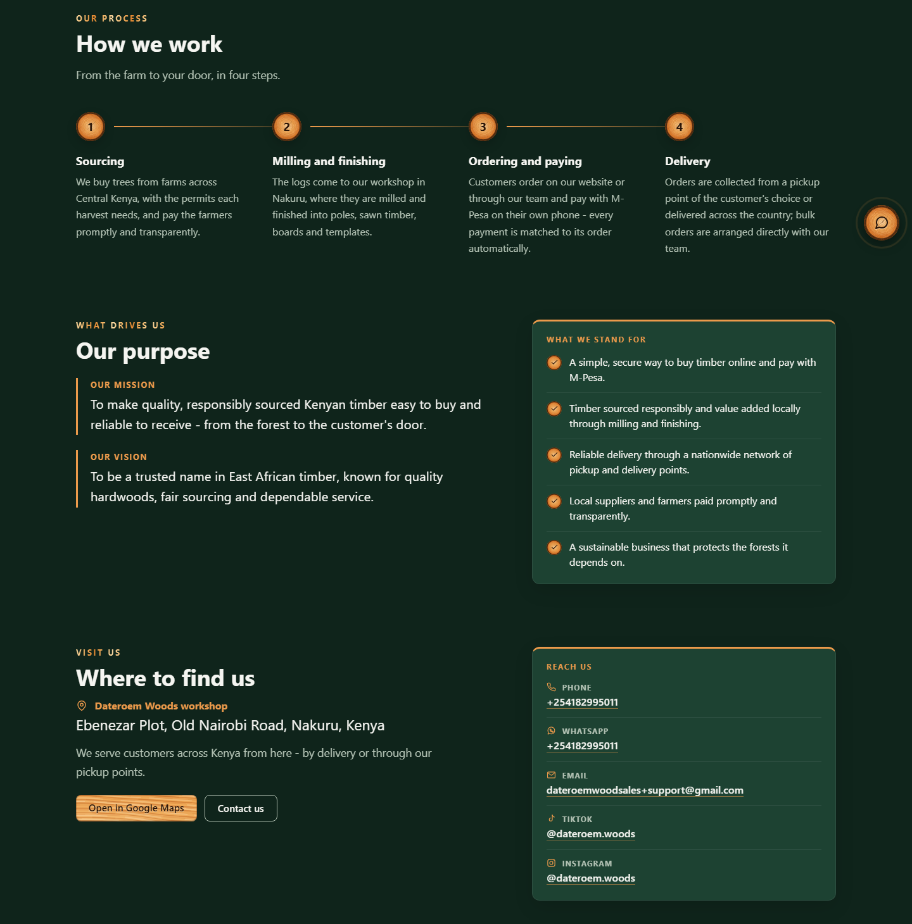
Figure 10: The About page: How we work, Our purpose with What we stand for, Where to find us with the Reach us card
The founder section (24 October 2026, the founder's own bio put in order and approved by the owner): the round portrait - cut from a clearer group photo, with only him in the frame - and under it a photo of him with a young tree ("this depict his love for trees"), captioned; beside them his story (founded in 2026 for the demand for timber in Nakuru; grew up in Timboroa, where timber milling was the main activity), the four reasons he started the business as a list (a steady supply; value added to raw timber, such as furniture; one central place to meet customers; customers choosing before supply), how he leads the purchasing team and the supply team, and his own closing words as a quote. On phones the order is portrait, the story, then the tree photo; the paragraphs are left-aligned there for easier reading. The words are ABOUT_FOUNDER in src/core/aboutStory.js (intro, aims, closing, quote, treePhoto, treeCaption). The shared contact card is components/ReachUs.jsx.

4.11 Help page and support email
The Help page's contact buttons sit right under the chat button, before the questions (since 7 October 2026; they used to be at the bottom of the page). The email button opens the Send us an email window (below); the address is shown under the buttons: dateroemwoodsales+support@gmail.com. That is the business Gmail (dateroemwoodsales@gmail.com) with a "+support" tag, so the mail arrives in the business mailbox and a Gmail filter files it under the Customers label. The page, the assistant and the fallback helper all read the contacts from the website server's settings (DWS-WEB-01).

4.12 Frequently asked questions
Since 7 October 2026 the Help page lists frequently asked questions below the chat button and the contact buttons (FaqSection in src/pages/HelpPage.jsx). They come from the website server (GET /help/faqs), grouped by topic in the order admins set, and admins keep them up to date in the desktop app (FAQs) - so a changed feature only needs its answer changed there, not the code.
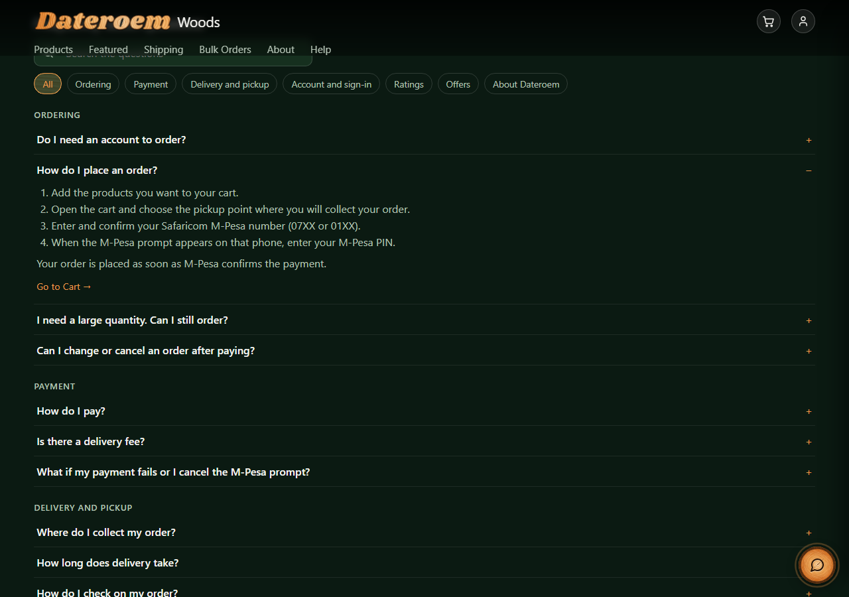
Figure 11: The Help page questions, one of them opened
- A search box: every word typed must appear in the question, answer or topic; capitals and punctuation don't count, so "mpesa pin" finds "M-Pesa PIN".
- Topic buttons (All, Ordering, Payment ...) show one topic at a time.
- Each question opens to its answer. Lines starting "1. ", "2. " show as numbered steps, and a question can end with a link to the page it is about ("Go to Shipping"), named as in the menu.
- With no questions, or when they can't be loaded, the section is left out; the chat and the contacts remain.

Where to adjust: Questions and answers: the desktop app, FAQs. Page names for links: PAGE_NAMES in src/pages/HelpPage.jsx and PAGES in the desktop app's ui/sections/faqs_section.py (keep them the same). Styles: .help-faq in src/styles/index.css.

4.13 Send us an email
Since 7 October 2026 a customer can write to the support team on the site itself - "just like what they would have done in their outlook or gmail web", without opening an email app (sent by the website server, see the Website Server document). "i want that email thingy to appear once some one clicks on the email": the form is a window over the page (src/components/EmailDialog.jsx), opened by the Send us an email button on the Help page and on the Bulk Orders page, where the subject starts as "Bulk order enquiry". While the website server has no email settings, the same buttons open the visitor's email app as before.
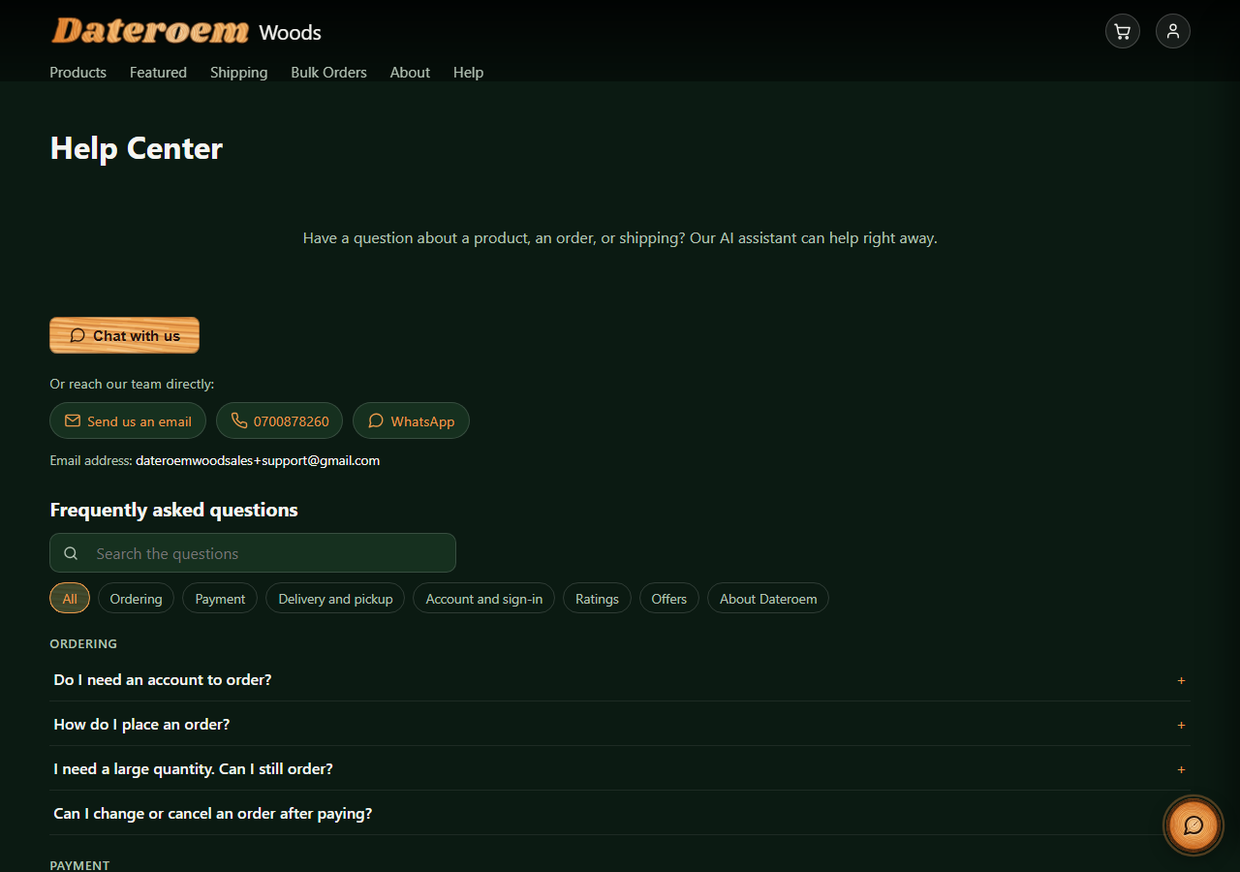
Figure 12: The Help page: chat button, then the contact buttons, then the questions
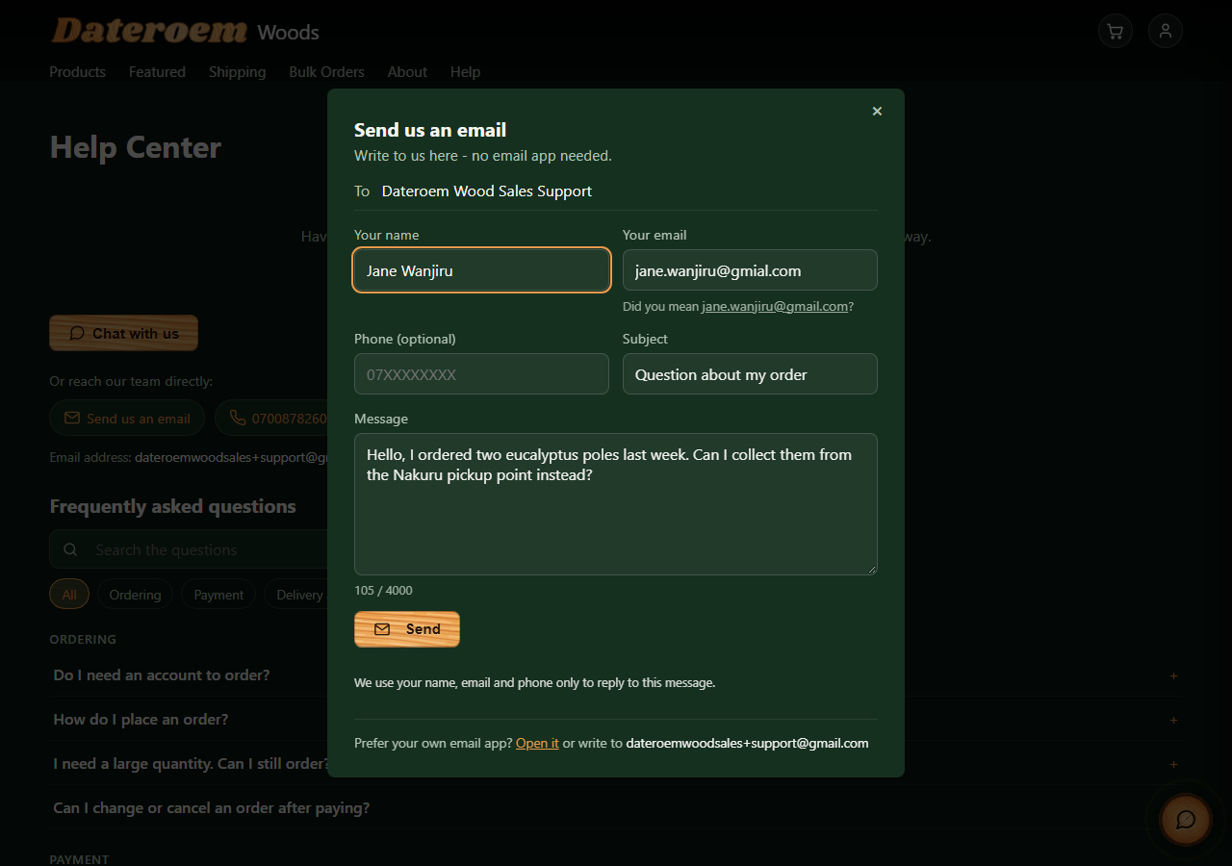
Figure 13: The Send us an email window (sample customer), with the suggestion for a mistyped address
- To is fixed (the support team); the customer fills in their name, email, an optional phone number, a subject and the message (10 to 4,000 characters, with a counter).
- Which desk (since 17 October 2026): the Help page writes to the support desk (+support); the Bulk Orders page to the orders desk (+orders), whose copies and replies also come from +orders.
- Signed in: the phone field starts with the phone number on the account.
- Signed in: name and email come from the account and can't be changed ("From your account - we reply here"). Not signed in: a mistyped address gets a suggestion, as at sign-up ("Did you mean ...@gmail.com?").
- After Send: "Sent", the address the reply will go to, and whether a copy (signed in) or a short confirmation (not signed in) is on its way; "Write another" clears subject and message.
- A hidden field only bots fill in, and the time the form was open, help the server spot automated sending.
- At the bottom, "Prefer your own email app? Open it" opens the visitor's email app with the subject and message typed so far, and the address is shown to copy.
- The window closes with the cross, Escape or a click outside it. Closing keeps what was typed until the page is left; after Send, Done closes it and the next one starts with an empty subject and message.

Where to adjust: Wording, fields and the Bulk Orders subject: src/components/EmailDialog.jsx and BULK_SUBJECT in src/pages/HeavyOrderPage.jsx. Styles: .email-modal and .help-email in src/styles/index.css.

4.14 Bulk order pictures
Since 9 October 2026 the Bulk Orders page shows what a bulk order looks like: "pictures that can be used to show case what bulk orders look like so that customers can see a template of what is meant by bulk orders ... like a slide". The pictures are not products; Marketers, Admins and the SuperAdmin keep them in Marketing in the phone and desktop apps (see those documents). With no pictures, the page is as before.
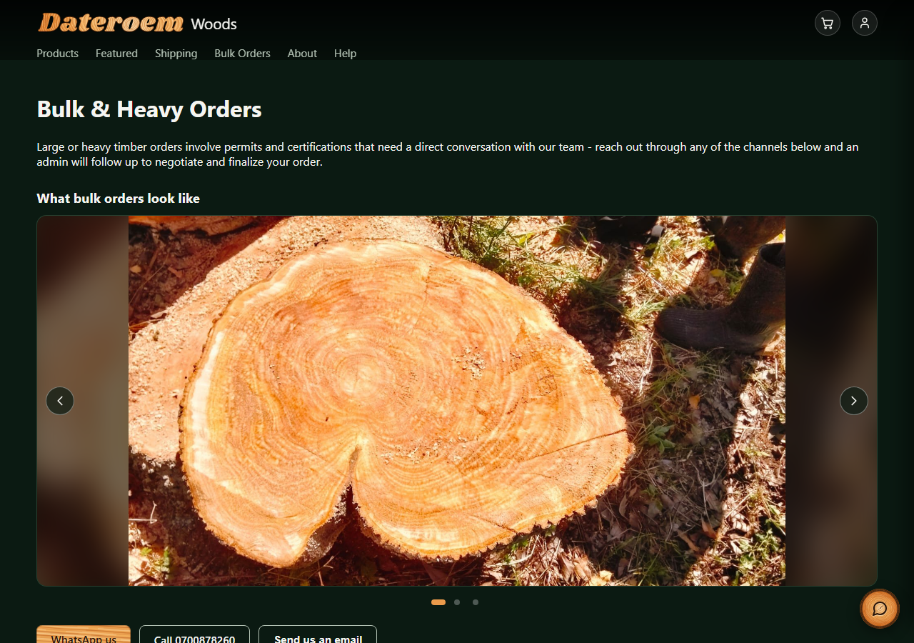
Figure 14: The Bulk Orders page with its slideshow (sample pictures)
- One picture at a time, cross-fading to the next every 5 seconds. It waits while the mouse is over it, a finger is on it or it has the keyboard focus, and while the tab is in the background; after any change the next one is a full 5 seconds away.
- Arrows at the sides, dots underneath (the current one a wood bar), the left and right arrow keys, and a swipe on a phone.
- Each picture is shown whole - upright phone photos are not cut - over a blurred, darkened copy of itself that fills the frame (16:9 on a computer, 4:3 on a phone). The caption, when there is one, sits along the bottom.
- Visitors who have asked their device for less motion get no automatic changes or fades: the picture stays until they move it.

Where to adjust: Timing and swipe distance: ADVANCE_MS and SWIPE_PX in src/components/ShowcaseSlider.jsx. Heading: src/pages/HeavyOrderPage.jsx. Styles: .showcase in src/styles/index.css.

4.15 Chat assistant and nudges
See the AI Assistant document (DWS-BE-04). Timings are in NUDGE_TIMING in src/context/ChatNudgeContext.jsx; one-tap questions are QUICK_QUESTIONS in src/components/HelpWidget.jsx.

4.16 The chat panel (forest look)
"the chat area not being so modern ... especially the color behind it make it look modern like we did with the rest of the site" (25 October 2026, approved on the local site and released the same evening). In the forest look the chat panel (HelpWidget.jsx, styles under "The chat" in styles/forest.css) has the site's misty forest behind it - the forest photo, drifting mist and a few fireflies, shaded so the words stay easy to read (a misty morning in Light, the forest at night in Dark).
- The header shows the company emblem in a round badge, "Dateroem assistant" and a green "Online · replies in seconds".
- Before the first question, a welcome ("Hi there!") with tap-to-ask suggestions - GENERAL_QUESTIONS in HelpWidget.jsx (delivery time, paying with M-Pesa, location, bulk orders); on a product, the cart or an empty search the page's own QUICK_QUESTIONS show instead.
- Questions sit in a wood-orange bubble on the right; answers in a frosted bubble on the left with the emblem beside them; a link in an answer is a rounded button with an arrow.
- The message bar is rounded, with a round send button (paper-plane icon) that lights up once there is something to send.
- Answers are laid out by src/core/chatAnswer.js: headings, bullets and numbered steps. A list the model writes on one line ("Delivery: - ... - ..." or "Here's how: 1. ... 2. ...") is unfolded first; product lines (name - KES price - stock) are never split.

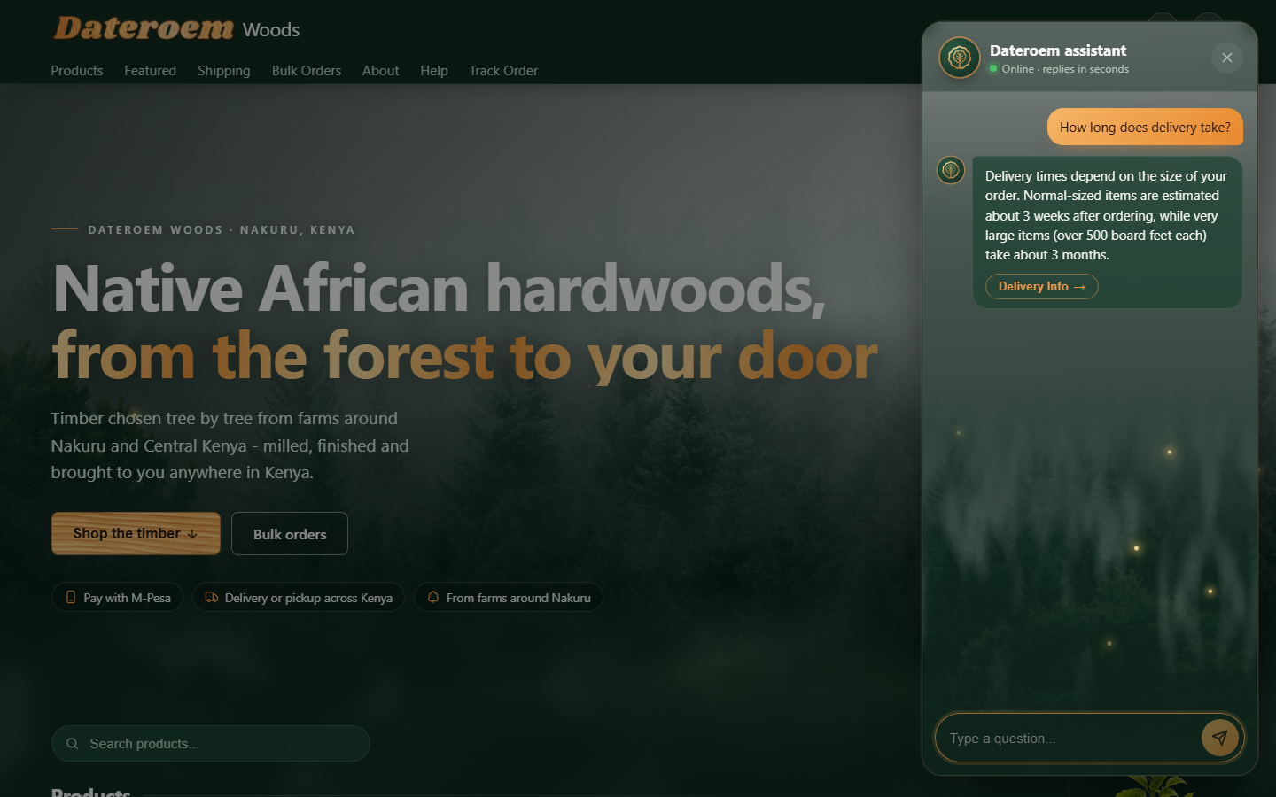
Figure 15: The chat in the forest look (live site)

5 Brand style

5.1 Company emblem
Since 7 October 2026 the company emblem is the one on the delivery lorry in the About film ("i want to use it as the company log"), redrawn as clean gold lines on near-black without changing its design ("enhance it ... without having to restructure it so much"): the end of a log with its wavy bark edge and growth rings, and a tree whose leafy canopy is the innermost ring. The drawing is code (src/brand/emblem.js) in two weights: full, with every ring, for large pictures, and bold (bark edge, canopy and tree, thicker lines) for small ones.

Figure 16: The social media profile picture (brand/Dateroem Woods profile picture.png)
File | Where it is used
public/favicon.svg, public/favicon.ico | The browser tab. Browsers draw tab icons in a fixed small square, so since 8 October 2026 the emblem fills all of it ("can we make it a little more visible ... without having to affect size allowed in the browser area"): its wavy bark edge is the outline of the icon, dark inside, with the thickest lines (tabIconSvg in src/brand/emblem.js). The page asks for favicon.svg?v=2; raise the number when the icon changes, or browsers keep showing the old one.
public/apple-touch-icon.png, public/icon-192.png, public/icon-512.png, public/manifest.webmanifest | Phone home screen when the site is added to it
public/brand/emblem.svg | The footer
brand/Dateroem Woods profile picture.png | TikTok and Instagram profile picture: emblem with DATEROEM WOODS below, 1080 x 1080, everything inside the circle the apps crop to
brand/Dateroem Woods profile picture (emblem only).png | The same without the name, for places the picture is shown very small
brand/Dateroem Woods logo.svg, .png, logo on dark.png | The emblem on its own (see-through and on dark), for anything else

Where to adjust: npm run brand:export (scripts/export-brand.mjs) makes all of these from src/brand/emblem.js. The lettering is Montserrat (brand/fonts, SIL Open Font License, free for logos).

5.2 Footer
"in the lower part of any page will have our socials there whatapp tiktok email and company telphone number": every page ends with the emblem, "Dateroem Woods" and the tagline, then WhatsApp, TikTok, Instagram, the email address (opens the Send us an email window) and the phone number (src/components/Footer.jsx). The contacts come from the website server (GET /help/contact); TikTok and Instagram (both @dateroem.woods since 8 October 2026) open in a new tab; either one is left out while its link is empty (SUPPORT_TIKTOK, SUPPORT_INSTAGRAM).
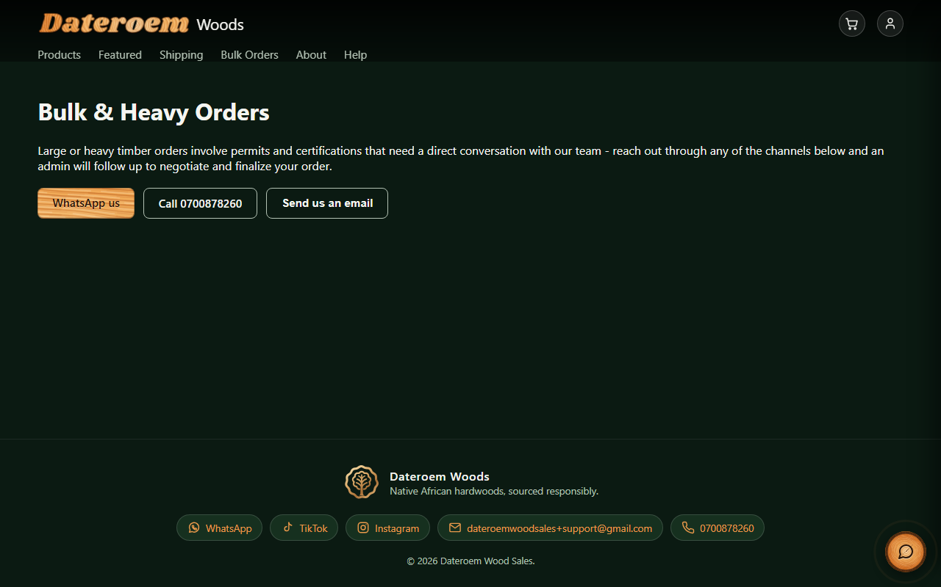
Figure 17: The footer, with the business TikTok and Instagram (@dateroem.woods)

5.3 Colours, wood and icons
- Forest-green theme with a painted-wood accent. Since 20 October 2026 the greens are "Living Forest", which the board chose after the older green was felt to be "too lazy and not lively": the page #0f241b, raised surfaces (cards, the cookie banner) #1d4232 and inner panels #173628 - the same values as the phone and desktop apps. Text on the page keeps a contrast of about 10:1, muted text about 6:1 and the wood about 5:1. The values are the variables at the top of src/styles/index.css (--bg, --bg-elevated); the browser bar colour (theme-color in index.html and the web manifest) follows the page green.
- Colour themes (since 20 October 2026: "is it possible to add more themes like the dark and light theme and what we have will be default"): Forest is the default, Dark is charcoal greys, Light is warm paper with dark text and a darker, barkier wood for small text. Every colour is a variable with a value per theme (html[data-theme] at the top of index.css); hairlines and faint tints use --ink-rgb (white on the dark themes, black on Light). The About story and the sign-in photo panel are built on dark photographs and keep the Forest colours in every theme. A small script in index.html applies the saved theme before the first frame, so a Light page never flashes green.
- One brush (src/wood/woodPaint.js) paints the Dateroem wordmark (whose letters form the rings of a cut log) and the plank and log-end textures used on buttons and highlights.
- npm run build first runs scripts/paint-wood-textures.mjs, so the textures always match the wordmark.
- npm run wood:export -- --mobile <mobile project> ... renders the same wood images for the mobile and desktop apps.
- All styles are in src/styles/index.css. Small "forest" motions (things growing into place) respect the reduced-motion setting.
- Icons are drawn line icons (src/components/Icon.jsx), not emojis.

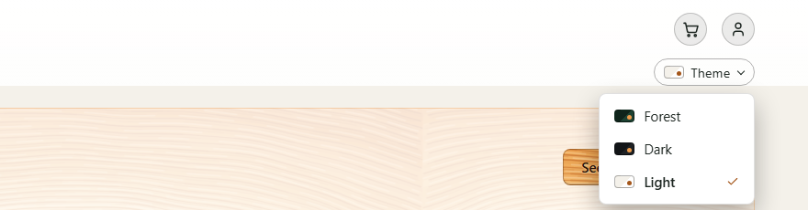
Figure 18: The Theme menu at the end of the top links (Light)
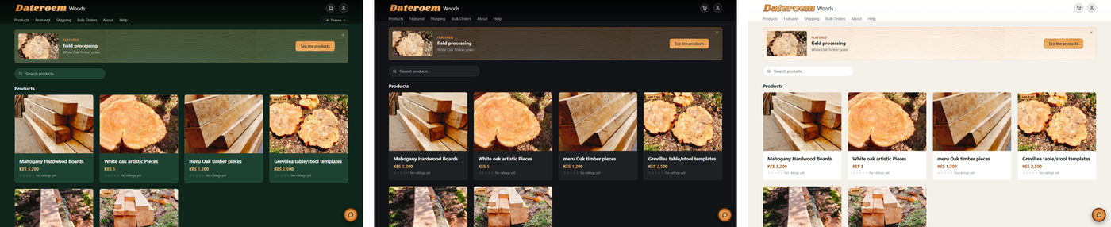
Figure 19: The products page in Forest, Dark and Light

5.4 The forest look
"the most modern look of the website to feel like an out of the world experience making one feel the ambience of the forests" (25 October 2026). It was built and tested on the preview on the company computer, approved by the owner and put live the same day. VITE_FOREST_LOOK=1 switches it on (see Configuration). Everything it adds is in src/components/forest/ and src/styles/forest.css and applies only while the page carries html[data-look="forest"], so setting 0 and releasing again brings back the classic look unchanged.
Where | What the visitor sees
Every page | A soft misty forest behind the page (the board's forest photo) with drifting mist, light through the canopy, leaf shadows and fireflies, all on one fixed layer (ForestAmbience). The top bar is solid. In Light the forest is a misty morning with specks of pollen; in Dark it is a forest at night.
Home: the entrance | The forest across the whole width with "Native African hardwoods, from the forest to your door", Shop the timber, Bulk orders and three promises - pay with M-Pesa, delivery or pickup across Kenya, from farms around Nakuru (ForestHero). On the first visit of a session it arrives like dawn: dark and out of focus, then sharp, then the words. Nothing on the page follows the scroll.
Home: the products | Each card is a piece of wood. It leans a little toward the mouse, rises into view further down the page, and has an amount (- 1 +), Add to cart and Order now (CardBuy). The amount stops at the stock less what is already in the cart; Order now adds the amount and opens the cart. "No ratings yet" stays on every card without ratings - the owner wants it shown.
Home: Featured | On screens 1280 px and wider, a slim column beside the products (FeaturedSapling): the owner's picture of a young tree with its roots in a ball of soil, the campaign's picture or video inside the soil with the roots over it, a tag on the stem with the campaign's name and See the products, and FEATURED above it. A video plays, without sound, while the mouse is over it. Narrower screens show a card above the products instead. Hide folds it into a FEATURED tab (or a Show featured button) that brings it back.
Product page | Leaf shadows moving over the photo; "From the forest to your door" in four steps with M-Pesa, the delivery time and the damaged-goods rule, in words taken from the About and policy pages (ForestJourney); and "More from the forest" - four other products, the same kind of wood first, with their ratings (ForestMore).

- Phones get a lighter version: no light shafts or leaf shadows, one layer of mist, a still background photo and fireflies only in the entrance (4). On a phone slowed four times, the fireflies were the main cost of scrolling; with this version scrolling runs at about 48-50 frames a second (the classic look about 60).
- Visitors who turn animations off on their device get a still forest.
- The pictures are in public/forest/. The forest pictures are made by brand/entrance photos/prepare_website_forest.py; the young tree by brand/featured/prepare_featured_plant.py from the owner's picture (brand/featured/plant-source.png), which removes the background and slims it.

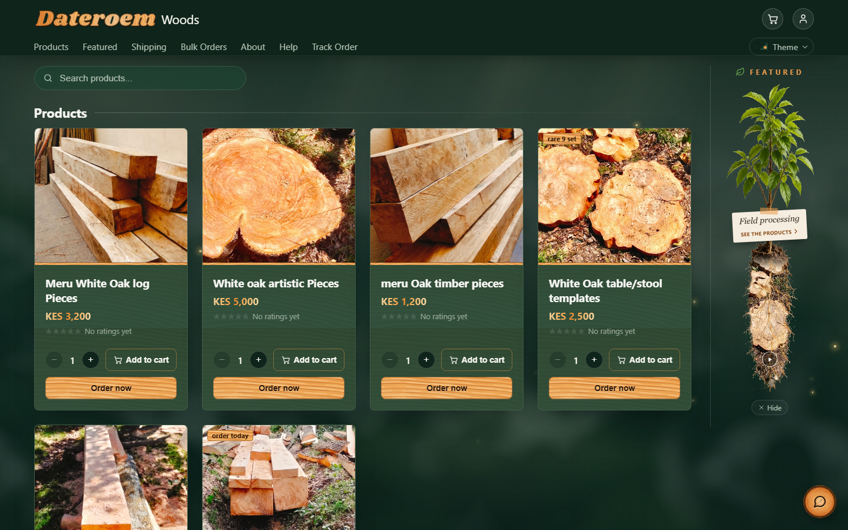
Figure 20: The products with Featured beside them (the forest look, live)
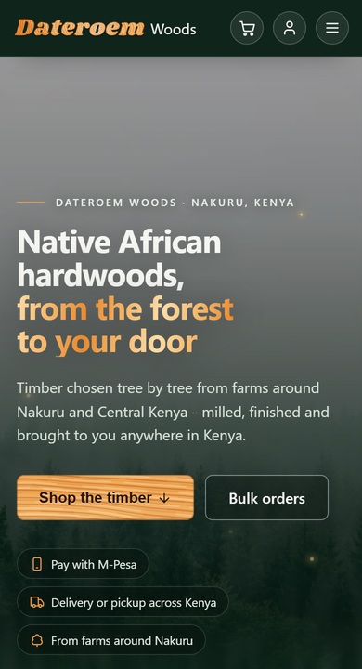
Figure 21: The entrance on a phone

6 Privacy and analytics
Only strictly necessary storage is used without consent: the sign-in token and the cart. The closed-banner and video-position notes are kept only in the visitor's own browser and are never sent anywhere. Google Analytics 4 (measurement id in VITE_GA_MEASUREMENT_ID) is loaded only after the visitor allows the analytics category. Chat nudge events (chat_nudge_shown, chat_opened_after_nudge, chat_nudge_dismissed) are recorded only for visitors who allowed analytics.

7 Configuration
Setting (frontend/website/.env) | Value today | Purpose
VITE_API_BASE_URL | empty | Empty means "same address as the page", using the /svc proxy. Set only if the website server lives elsewhere.
VITE_GA_MEASUREMENT_ID | the company GA4 id | Google Analytics property; blank disables analytics.
VITE_FOREST_LOOK | 1 (in .env.production) | The forest look (since 25 October 2026); 0 and a new release bring back the classic look. The preview on the company computer (vite dev, port 5199) reads .env.development.local.

Note: Vite settings are read at build time. After changing .env, rebuild the public site (restart "Website (public build)" in the desktop Servers section).

8 Build, preview and publish
cd /root/fathersProject/frontend/website
npm install # first time only
npm run dev # development: http://localhost:5173
npm run build # production files in dist/
npx vite preview --port 4173 # serve dist/ (what the public sees)
Since 25 October 2026 the HostAfrica server serves the public site: a release (make-release.sh on the company computer, install-release.sh on the server - see the Hosting and Deployment Guide) builds dist/ with .env.production, and the router there serves it at https://dateroemwoods.co.ke. On the company computer, npm run dev and the preview on port 5199 are for trying changes before a release.

8.1 When something goes wrong
"in the event of an error e.g the server is offline ... the user ... never gets the whole details but what is necessary and presentable" (18 October 2026). Every message a visitor sees comes from apiErrorMessage in src/api/client.js: the server's own reason when it is meant for people ("Not enough stock ...", "That code isn't right"), otherwise one calm sentence - "We can't reach Dateroem right now. Please try again in a few minutes." (server down), "Something went wrong on our side. Please try again in a moment." (a problem on the server), "You seem to be offline ..." (no connection), or a plain sentence for "please sign in again", "you don't have access", "too many tries". Never a status code, a raw reply or browser error text.
While the website itself is down, the router answers the page with "We'll be right back" - the company emblem, a short note, the company number to call or WhatsApp - and reloads it by itself once the site is back (see the Running and Operating document).
Where to adjust: The sentences: OFFLINE, UNREACHABLE, PROBLEM and BY_STATUS in src/api/client.js.

9 Development history
Date | Change
2026-09-11 | frontend/website created; first React website built from the business rules.
2026-09-12 | Sample data, product photos from the media folder, back arrow on product pages, opening animation.
2026-09-13 | Forest theme and layout, marketer badges on products, AI help area (first as a keyword bot), over-ordering blocked by stock checks.
2026-09-16 | Marketing page as playable cards.
2026-09-17 | Public access through ngrok, phone-friendly layout, Google Analytics behind cookie consent, side-panel help chat, cart icon, M-Pesa STK push at checkout (sandbox).
2026-09-18 | STK payment confirmed end to end (callback and status query), Ordered Goods page, customer-specific order numbers, size-based delivery estimates.
2026-09-24 | No order without a successful payment prompt, phone number checked before paying, cart kept on refresh, full-page delivery area picker with "near me" and map coordinates, product grid, Ordered Goods cards.
2026-09-25 | Painted-wood brand style (website, then mobile and desktop); delivery area shown on desktop order rows; USB phone link re-applied automatically.
2026-09-26 | Product ratings and reviews with a public-review agreement, long descriptions with an AI-arranged layout, delivered goods ordering, splash removed, gentle forest motion, emojis replaced by icons.
2026-09-27 | Phone number required at sign-up; About page with the scroll-played journey from tree to doorstep.
2026-09-29 | Sign in with Google alongside username and password.
2026-10-02 | AI chat nudges at helpful moments, with the page context passed to the assistant.
2026-10-03 | Help page support email set to the business Gmail's +support address, shown as "Dateroem Wood Sales Support".
2026-10-03 | The customer "Marketing" tab became "Featured": only campaigns that are running (Active, within their dates, with products), the tab shown only while one is; a closable banner on the Products page and a tag on featured products.
2026-10-03 | Product pages: "All products" link, the campaign shown in a card under the product details (the video at its own shape with a soft glow either side), video position remembered between pages.
2026-10-03 | New sign-in screen with the About film beside the form; sign in with username or email; email addresses checked at sign-up (format, mail domain, not already used) with typo suggestions; "+" addresses accepted.
2026-10-03 | Google sign-in switched on with the Dateroem Google Cloud client; new Google users choose their own username.
2026-10-03 | The "5 ratings", "Featured in" and "Read the full description" links keep their section in view while the page finishes loading.
2026-10-07 | Help page: frequently asked questions with a search box and topic buttons, each answer able to link to the page it is about; the first 16 written from the facts the website's assistant is given. Admins keep them in the desktop app (FAQs).
2026-10-07 | Help page: "Send us an email" form - the customer types the email on the site and it reaches the support inbox through the business Gmail (App Password), with their name as sender and Reply going to them; a confirmation reaches their inbox. Nothing is stored.
2026-10-07 | The Send us an email form opens as a window from the email button on the Help and Bulk Orders pages (there with the subject "Bulk order enquiry"), with a link to the customer's own email app; the Help page contacts moved above the questions.
2026-10-07 | Company emblem: the emblem on the delivery lorry in the About film, redrawn as a clean gold logo (log rings and a tree). It is the browser tab and phone home-screen icon; profile pictures for TikTok and Instagram are in brand/. Every page ends with a footer: the emblem, then WhatsApp, TikTok, Instagram, email and phone.
2026-10-08 | Footer links to TikTok and Instagram (@dateroem.woods); the browser tab icon enlarged to fill its whole square.
2026-10-09 | Retire a product: an admin takes a product off the shop from the desktop or phone app, whatever its stock, and can bring it back later; its stock and existing orders are kept. Products that run out of stock are listed for admins under "Needs attention", with a count on Products in the phone app menu.
2026-10-09 | Bulk order pictures: example photos of real bulk orders play as a slideshow on the website's Bulk Orders page (whole picture, optional caption, moves on every 5 seconds). Marketers, Admins and the SuperAdmin add, caption, put in order and remove them from Marketing in the phone and desktop apps; 12 at most.
2026-10-17 | Bulk Orders emails go to the orders desk (the +orders address), and its replies come from there; the Help page keeps +support. A signed-in customer's phone number is filled in for them in the email window and at checkout.
2026-10-17 | Phone numbers confirmed by an SMS code (Africa's Talking): a 6-digit code at sign-up (password or Google) and, for accounts made before, once before the first order; checkout fills in only a confirmed number. Live for Airtel numbers only until Dateroem has its own SMS sender name; other numbers are taken as typed, as before.
2026-10-18 | Calm error messages everywhere ("the user ... never gets the whole details but what is necessary and presentable"): the website, the phone app and the three servers show one plain sentence when the server is down, slow or has a problem - never addresses, codes or error text; the backend no longer sends stack traces; while a server is down the router shows a "We'll be right back" page (and the apps a short message).
2026-10-20 | The product grid and the Featured banner fill the page at any width, the cards growing with the screen ("instead of fixating on a certain length can it stretch automatically"); the cookie banner's Customize is a wood link instead of a warning red.
2026-10-23 | The About page sets out the company: who we are with the registered facts, how we work (timber from farms across Central Kenya, milled in Nakuru), where to find us with the owner's map pin, and the founder with a photo frame; the same facts for search engines in index.html.
2026-10-25 | The forest look ("the most modern look of the website ... making one feel the ambience of the forests"): the forest behind every page, a forest entrance, wood product cards with an amount, Add to cart and Order now, Featured as the owner's young tree with the campaign inside its soil beside the products, and the product page's journey and More from the forest. Built on the preview, approved and released the same day; VITE_FOREST_LOOK in .env.production switches it.
2026-10-25 | The modern chat ("especially the color behind it make it look modern like we did with the rest of the site"): the site's forest behind the chat, an emblem header with Online, a welcome with suggestions, frosted bubbles, a rounded message bar; the assistant learnt the company facts (it used to decline "Where are you located?") and asks again when an answer stops after promising details.

